

Name: Sajjal Tariq
Roll No: 10011
Section: A
Submitted To: Sir Zohaib Khan

LAB NO. 03
Introduction to Data Manipulation Language (DML) Commands and Creating a Sample Database

To study the various data manipulation language commands and
implement them on the database

Instructions
▪ This is individual Lab work/task.
▪ Complete this lab work within lab timing.
▪ Discussion with peers is not allowed.
▪ You can consult any book, notes &amp; Internet.
▪ Copy paste from Internet will give you negative marks.
▪ Lab work is divided into small tasks, complete all tasks sequentially.
▪ Show solution of each lab task to your Lab Instructor.
▪ Paste your solution (i.e. code) in given space under each task.
▪ Also make a zip/rar archive of all lab tasks and upload this file on LMS before
leaving lab.
▪ In-Lab Exercises/Tasks
FACILITIES REQUIRED AND PROCEDURE
Facilities required to do the experiment
S.No
.
Facilities Required Quantity
1 System 1
2 Operating System Windows 10
3 Front End Java
4 Back End Oracle 11g, MySQL
Procedure for doing the experiment
Step Detail
1 DML Commands
DML commands are the most frequently used SQL commands and is
used to query and manipulate the existing database objects. DML
statements are used for managing data in database. DML commands
are not auto-committed. It means changes made by DML command
are not permanent to database, it can be rolled back.
Some of the commands are:
Select
Insert
Update
Delete

2 Select Command
It is used to retrieve information from the table. it is generally referred
to as querying the table. We can either display all columns in a table
or only specify column from the table.

3 Insert Command
This is used to add one or more rows to a table. The values are
separated by comma and the data types char and date are enclosed
in apostrophes. The values must be entered in the same order as they
are defined.

SQL COMMANDS

Insert Command
Inserting a single row into a table:
Syntax: insert into &lt;table name&gt; values (value list)
Example: insert into s values („s3‟,‟sup3‟,‟blore‟,10)

Inserting more than one record using a single insert commands:
Syntax: insert into &lt;table name&gt; values (&amp;col1, &amp;col2, ....)
Example: Insert into stud values(&amp;reg, „&amp;name‟, &amp;percentage);

Skipping the fields while inserting
Just give “null” while passing the values as:
Insert into &lt;table name&gt; values (1,’Ali khan’,’null’,’karachi’)

Inserting default value in a column
Just give “default” while passing the value so, whatever the default value will be of that
column, it will be inserted. For example:
Insert into &lt;table name&gt; values (1,’Ali khan’,’default’)
Select Command
Selects all rows from the table:
Syntax: Select * from tablename;
Example; Select * from IT;
The retrieval of specific columns from a table:
It retrieves the specified columns from the table.
Syntax: Select column_name1, .....,column_namen from table name;
Example: Select empno, empname from emp;

Elimination of duplicates from the select clause:

It prevents retriving the duplicated values .Distinct keyword is used.
Syntax: Select DISTINCT col1, col2 from table name;
Example: Select DISTINCT job from emp;

Select command with where clause:
To select specific rows from a table we include „where‟ clause in the select command. It
can appear only after the „from‟ clause.
Syntax: Select column_name1, .....,column_namen from table name where condition;
Example: Select empno, empname from emp where sal&gt;4000;

Select command with order by clause:
Syntax: Select column_name1, .....,column_namen from table name where condition
order by colmnname;
Example: Select empno, empname from emp order by empno;

Select command to create a table:
Syntax: create table tablename as select * from existing_tablename;
Example: create table emp1 as select * from emp;

Select command to insert records:
Syntax: insert into tablename ( select columns from existing_tablename);
Example: insert into emp1 ( select * from emp);

Assignment:
Study various datatypes provided by Oracle technologies for database and I can ask
questions about them from anybody in the next lab.

Extra Tasks
TASK NO 01:
Q1. Create a table called Salesman with the following structure.
Name Type
---------- ----------------------
SAL-ID NUMBER(6)
NAME VARCHAR2(20)
CITY VARCHAR2(10)
COMMISION NUMBER(3)
Allow NULL for all columns except ename and job.
Code:
CREATE TABLE salesman (
2 SAL_ID NUMBER(6),
3 NAME VARCHAR2(20) NOT NULL,
4 CITY VARCHAR2(10),
5 COMMISION NUMBER(3)
6 );
Screenshot:
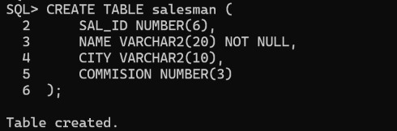
TASK NO 02:
Q2. Write a SQL statement to display all the information of all salesmen.
Code:
SELECT * FROM salesman;
Screenshot:
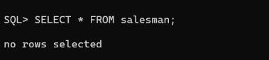
TASK NO 03:
Q3. Write a query to display three numbers in three columns.
Code:
SQL> SELECT 1 AS num1, 2 AS num2, 3 AS num3 FROM DUAL;
Screenshot:
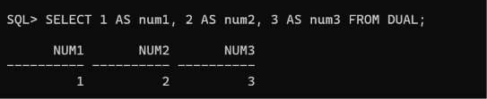

TASK NO 04:
Q4. Write a query to display the sum of two numbers 10 and 15 from RDMS sever
Code:
SQL> SELECT 10 + 15 AS SUM FROM DUAL;
Screenshot:
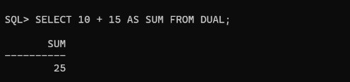

TASK NO 05:
Q5. Write a query to display the result of an arithmetic expression.
Code:
SELECT (2 * 5) - 10 AS RESULT FROM DUAL;
Screenshot:
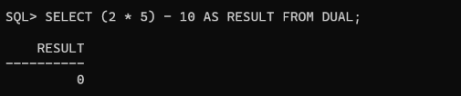
Q6. Write a SQL statement to display specific columns like name and commission for all the salesmen.
Code:
SELECT NAME, COMMISION FROM SALESMAN;
Screenshot:
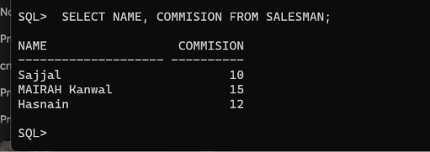

Q7. Write a SQL statement to display names and city of salesman, who belongs to the city of Paris.
Code:
SELECT NAME, CITY
2 FROM SALESMAN
3 WHERE CITY = 'Paris';
Screenshot:
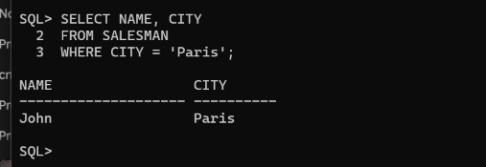

Q8. Write a SQL statement to display all the information for those customers with a
commission of 200.
Code:
SQL> SELECT *
2 FROM CUSTOMER
3 WHERE COMMISSION = 200;
FROM CUSTOMER
Screenshot:
